**NAME:** Tuedem Wafo Leslie F.

**HITBAMAS swe level 2**

**Assignment**

1. **Calculator**

Create a calculator in Vb.net.

Module Module1

Sub Main()

Dim a As Integer

Dim b As Integer

Dim sum As Integer

Dim mul As Integer

Dim subt As Integer

Dim div As Double

Dim op As Integer

Console.WriteLine("Which operation will you like to carry out (1, 2, 3, 4)?")

Console.WriteLine("+(1) , -(2) , *(3) , /(4)")

op = Console.ReadLine()

Console.WriteLine("Enter value a:")

a = Console.ReadLine()

Console.WriteLine("Enter value b:")

b = Console.ReadLine()

Select Case (op)

Case 1

sum = a + b

Console.WriteLine("The sum is {0}", sum)

Case 2

subt = a - b

Console.WriteLine("The difference is {0}", subt)

Case 3

mul = a * b

Console.WriteLine("The product is {0}", mul)

Case 4

div = a / b

Console.WriteLine("The quotient is {0}", div)

Case Else

Console.WriteLine("You entered an invalid value!")

End Select

Console.ReadKey()

End Sub

End Module

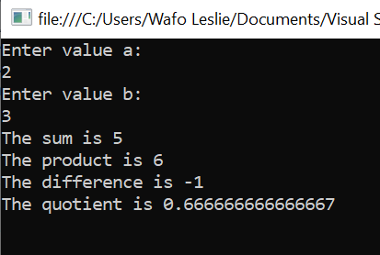

1. **Grades**

Write a program that asks the user to enter his grades (A, B, C, D, F) and display the following comments: Excellent job, Good job, Fair job, Need improvement, You failed.

Module Module1

Sub Main()

Dim grade As Char

Console.WriteLine("Please enter your grade (A, B, C, D, F) : ")

grade = Console.ReadLine

Select grade

Case "A"

Console.WriteLine("Excellent job!")

Case "B"

Console.WriteLine("Good job!")

Case "C"

Console.WriteLine("Fair job!")

Case "D"

Console.WriteLine("Need improvement!")

Case "F"

Console.WriteLine("You failed!")

Case Else

Console.WriteLine("You entered an invalid grade!")

End Select

Console.ReadKey()

End Sub

End Module

1. 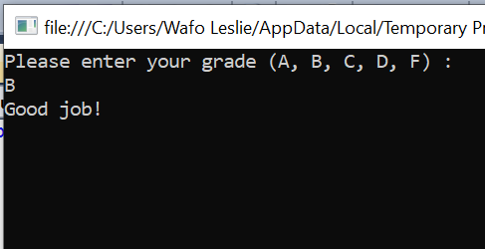**Stars**

Module Module1

Sub Main()

Console.WriteLine("*****")

Console.WriteLine("*****")

Console.WriteLine("*****")

Console.WriteLine("*****")

Console.WriteLine("*****")

Console.ReadKey()

End Sub

End Module

1. 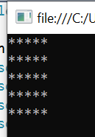**Age group**

Write a program that asks the user to enter their age. If age is less than 18, display you are a minor otherwise display you are an adult.

Module Module1

Sub Main()

Dim age As Integer

Console.WriteLine("How old are you? ")

age = Console.ReadLine

If (age < 18) Then

Console.WriteLine("You are a Minor!")

Else

Console.WriteLine("You are an Adult!")

End If

Console.ReadKey()

End Sub

End Module

1. 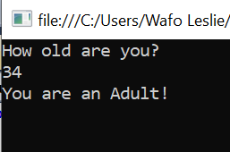**Retirement**

Module Module1

Sub Main()

Dim age As Integer

Console.WriteLine("Enter your age: ")

age = Console.ReadLine

If age >= 60 Then

Console.WriteLine("You are due for retirement")

Else

Console.WriteLine("You are not yet due for retirement")

End If

Console.ReadKey()

End Sub

End Module

1. 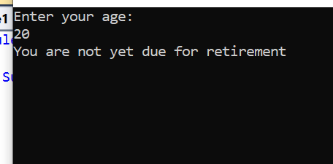**Form**

Public Class Form1

Private Sub Form1_Load(ByVal sender As System.Object, ByVal e As System.EventArgs) Handles MyBase.Load

'TODO: This line of code loads data into the 'RegistrationDbDataSet.Registration_Table' table. You can move, or remove it, as needed.

Me.Registration_TableTableAdapter.Fill(Me.RegistrationDbDataSet.Registration_Table)

End Sub

Private Sub Registration_TableBindingNavigatorSaveItem_Click(ByVal sender As System.Object, ByVal e As System.EventArgs) Handles Registration_TableBindingNavigatorSaveItem.Click

Me.Validate()

Me.Registration_TableBindingSource.EndEdit()

Me.TableAdapterManager.UpdateAll(Me.RegistrationDbDataSet)

End Sub

End Class

1. 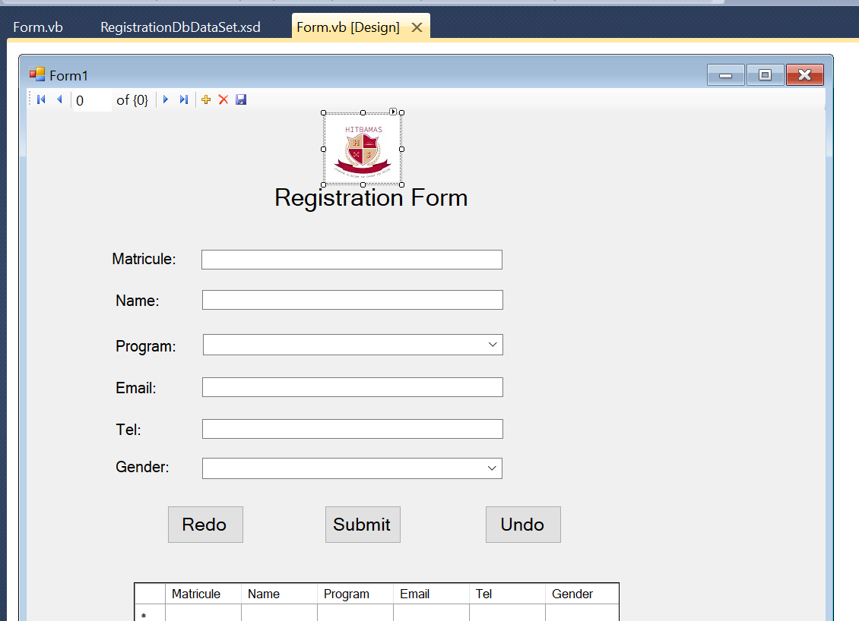Write a program that takes an integer from a user and prints its multiplication table from 1 to 12.
2. Module Module1
3. Sub Main()
4. Dim num As Integer
5. Dim i As Integer
6. Dim pro As Integer
7. Console.WriteLine("Enter a number: ") 'number whose multiplication table should be printed
8. num = Console.ReadLine()
9. Do While i < 13
10. pro = num * i
11. Console.WriteLine("{0} * {1}={2}", num, i, pro)
12. i += 1
13. Loop
14. Console.ReadKey()
15. End Sub
16. End Module

**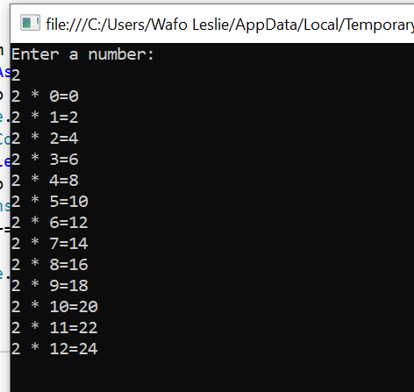  
8.** Write a program that takes an integer as input and calculate its factorial using a loop.

Module Module1

Sub Main()

Dim num As Integer

Dim i As Integer

Dim fac As Integer

fac = 1

Console.WriteLine("Enter a number")

num = Console.ReadLine()

For i = 1 To num

fac = fac * i

Next

Console.WriteLine("The factorial of {0} is {1}", num, fac)

Console.ReadKey()

End Sub

End Module

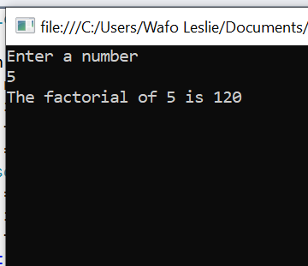

9. Write a program that takes an input and prints the Fibonacci series up to that n.

Module Module1

Sub Main()

Dim a, b, num, sum As Integer 'fibonacci

Console.WriteLine("Enter the number of values you want to print from the fibonacci sequence:")

num = Console.ReadLine() 'where to end printing

a = 0 'cuz fibonacci starts from 0

b = 1 'after is 1

Console.WriteLine("Fibonacci :")

Console.WriteLine("{0}", a)

Console.WriteLine("{0}", b)

For i = 1 To num - 2 'num-2 cuz the first two numbers 0 and 1 are added already

sum = a + b

Console.WriteLine("{0}", sum)

a = b

b = sum

Next

Console.ReadKey()

End Sub

End Module

